Practical physiology Pulmonary function and respiratory regulation
' by Dr hind .A.j PFR

The respiratory system of the body (lungs ,airways and muscles) is not directly involved in this process, rather it is involved in the exchange of O2and CO2 between the blood (brought to the alveoli in the lungs) and the inspired air (filling the alveoli in the lungs)
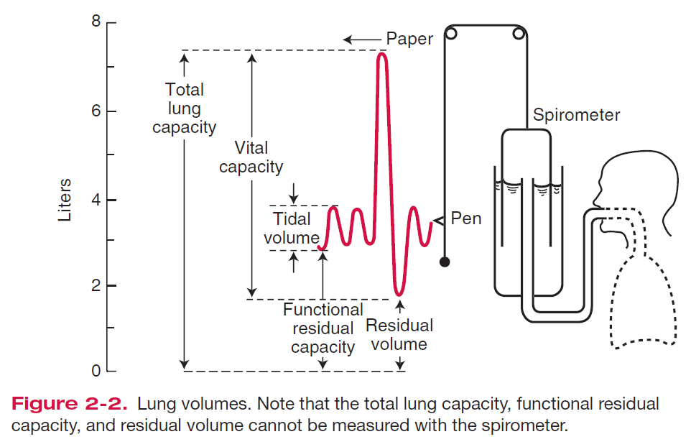
Respiration is composed of four steps
1-ventilation (or breathing)
2-gas exchange in the lungs.
3-circulation of blood between the lungs and tissues.
4-gas exchange at between ,the blood and tissues.
Breathing
During inspiration ,air is forced into the lungs due to expansion of the thoracic cavity .Expansion of the thoracic cavity s caused by the contraction of the diaphragm at the bottom of the rib cage and the contraction of the external intercostal(between rib) muscles, causing the ribs to move upwards and outwards. The expansion of the thoracic cavity increases thoracic volume and decreases thoracic pressure so that the net flow of air is down its pressure gradient and into the lungs .during exercise, the body's need for oxygen increases dramatically and ventilation rate is increased .The depth of breathing also increases during exercise due to the anatomical dead space of the respiratory system .The anatomical dead space is the air in the nose ,mouth, larynx ,tracheas .bronchi and bronchioles .This air reaches the alveoli first upon inspiration.
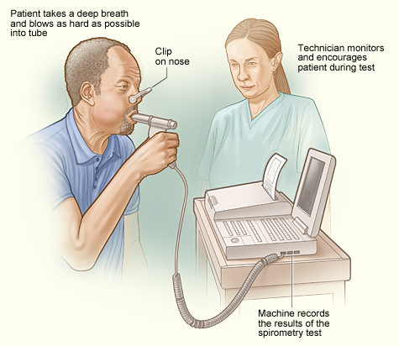

Spirometry

Is method for measuring lung volumes during ventilation .it is used to assess lung function and is particularly helpful for diagnosing obstructive lung diseases .two types of lung disorders can be identified by Spirometry measurements
1-obstructive lung disorders such as bronchitis and asthma .in these condition ,there is an obstructive process in the air ways (the bronchi)of the lung and this is detected by a decreased ability to empty the lungs quickly during a forced expiration this is measured as the FEV+/VC ratio.
2-Restrictive lung disorders are characterized by a decrease in lung compliance ,in diseases such as emphysema ,which result in reduced alveolar volume. Abnormal VC measurements are not necessarily accompanied by alteration in the FEV1/VC ratio.
Lang diseases are not of one specific type .but rather result from a combination of the above two disorders or in combination with a variety of factors that lead to compromised respiratory function .these factors can include neuromuscular disorders which compromise the inspiratory and expiratory muscles ,dysfunction of the respiratory control center in the brain stem ,or some other defect relating to gas exchange across the lung airways or in the blood .
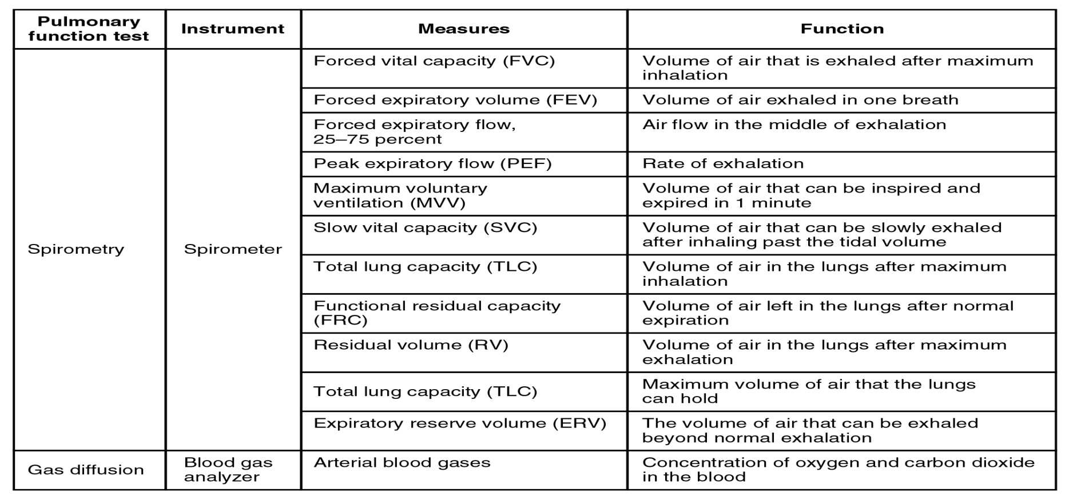
Typical volume and flow rate patterns(mL)

Restrictive disease | Obstructive disease | Normal | Volume  (mL)
5000 | 8000 | 6000-7500 | Total lung capacity(TLC)
4000 | 4000 | 6000 | Vital capacity (VC)
3500 | 1800 | 4800 | FEV1
88 | 50 | 80 | FEV1/VC(%)

Typical recording of various lung volumes from a recording spirometer
